Selected Brand: New Balance

PART 1: CONTEXT
Criteria | Responses
Brand Evaluated | New Balance is a global brand that sells performance footwear, athletic apparel, and lifestyle sneakers for sports, fitness, and everyday wear.
Link to Website | https://www.newbalance.com
Brand Voice | New Balance’s brand voice is authentic, grounded, and purposeful. The character of the brand centers on heritage and innovation, reflected in language that emphasizes craftsmanship, performance, and independence. The tone is calm yet confident, often avoiding overhyped or exaggerated claims in favor of thoughtful and informative messaging. The language is direct, using industry-specific vocabulary when discussing product features (e.g., Fresh Foam, FuelCell) while still remaining accessible. The brand’s purpose is to inspire consumers to move with confidence, whether that’s running marathons or walking the city streets, with products that align comfort, style, and function.
Goals (AIDAR) | 1. Interest: To generate user interest through engaging visuals and detailed descriptions of new product releases and collaborations, leading to product exploration.  2. Conversion: To drive online purchases by emphasizing premium materials, performance technology, and limited-edition offerings to encourage action.
Target Audience | A key target audience is health-conscious, style-aware adults aged 25–35, particularly urban professionals or fitness enthusiasts who value both performance and sustainability. These consumers are digitally active and often research products before purchasing. They care about the technical quality of running or lifestyle shoes and appreciate brands with social responsibility (e.g., New Balance’s “Green Leaf” standard). Many seek a balance between athletic utility and streetwear aesthetics, often buying sneakers that can transition from workouts to casual outings. They are often influenced by social media trends and product reviews from reputable sources or influencers.

PART 2: Website & SEO Evaluation
Best Practices Found (4 Examples)
Best-Practice Checklist | Best Practices Found (2 sentences) | Screen Grab
Website – Content / Conversion CTA | The homepage displays a pop-up offering 10% off for first-time visitors in exchange for their email. This reflects strong call-to-action (CTA) and list-building strategy. | 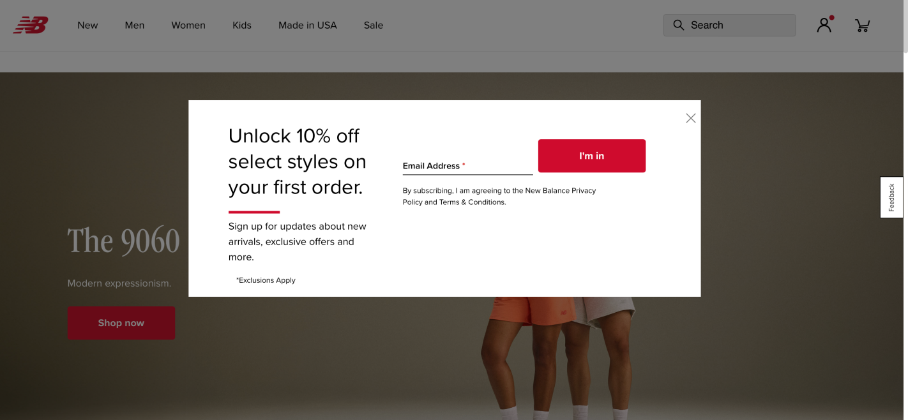
Website – Look and Feel | The site uses clean, modern photography and a minimalist aesthetic to highlight products, especially on hero banners like “The 9060.” This aligns with design best practices. | 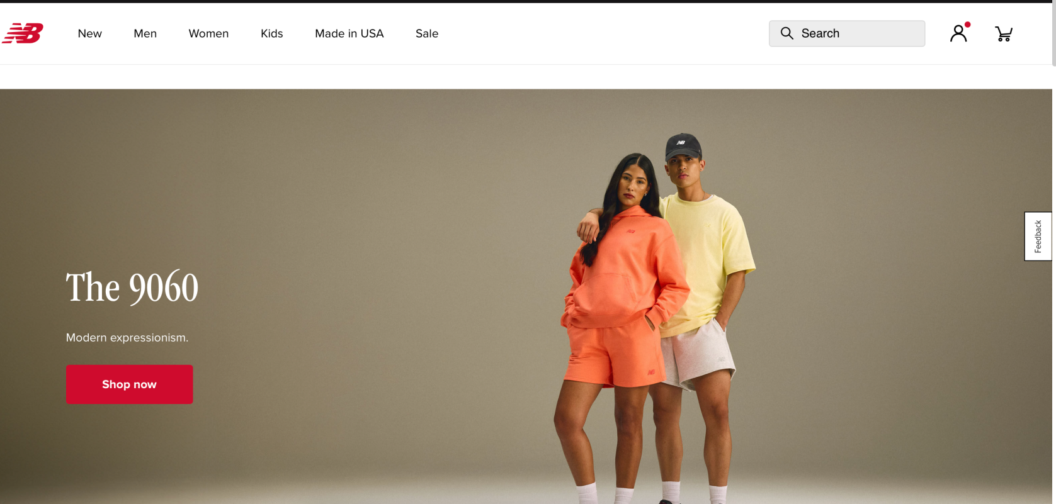
SEO – Page Construction | The “Shop by Category” layout (with running categories like trail, road, and everyday) demonstrates content structuring that supports keyword-rich linking and internal navigation. | 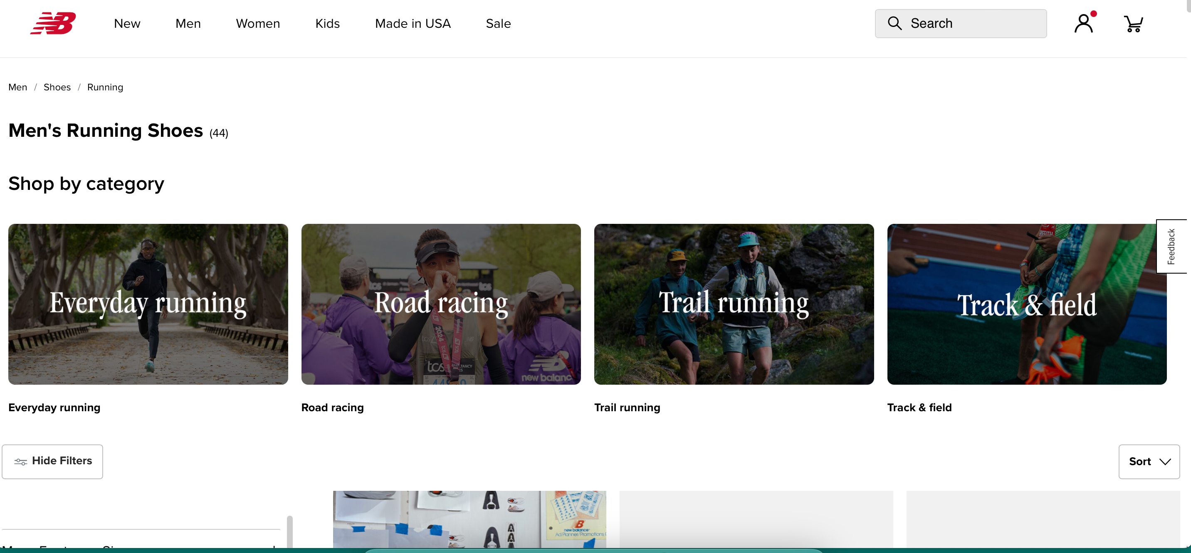
SEO – Engagement | The footer offers multiple engagement paths—sign-ups, social media icons, and New Balance’s mission statement—helping boost dwell time and reinforcing trust signals. | 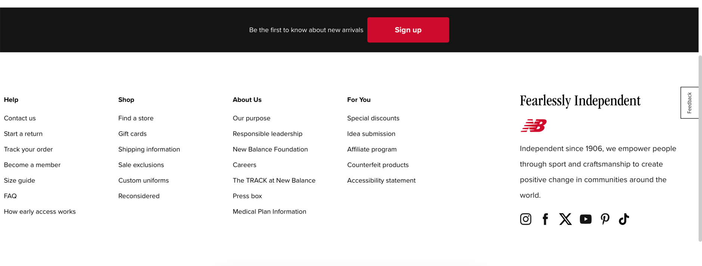

Issues Found (4 Examples)
Best-Practice Checklist | Issues Found (2 sentences) | Screen Grab
Website – Navigation | While product categories are accessible, filters and search refinement options are not prominently visible on all category pages, possibly reducing usability.
Website – Load Speed or Content Optimization | The “Trending Now” section features high-resolution images with minimal descriptive text, potentially affecting page load time and SEO keyword density. | 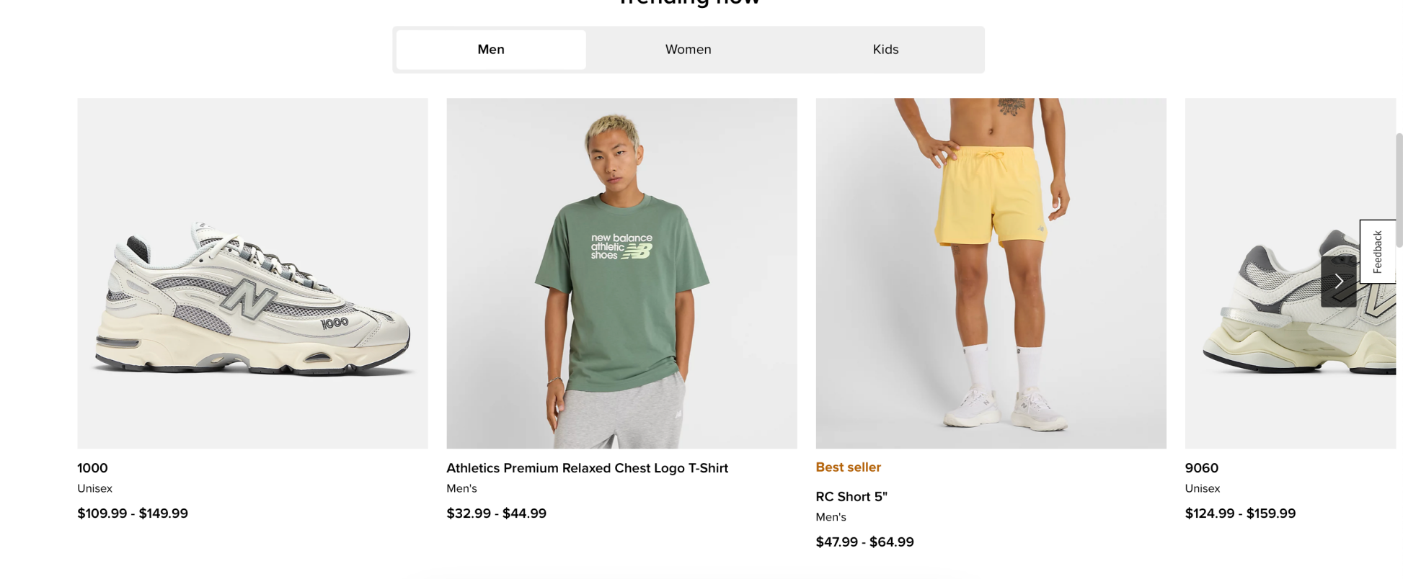
SEO – SERP Visibility | The “Made in USA” collection page has great content but lacks unique meta titles or structured data on the visible page, which could limit SEO performance. | 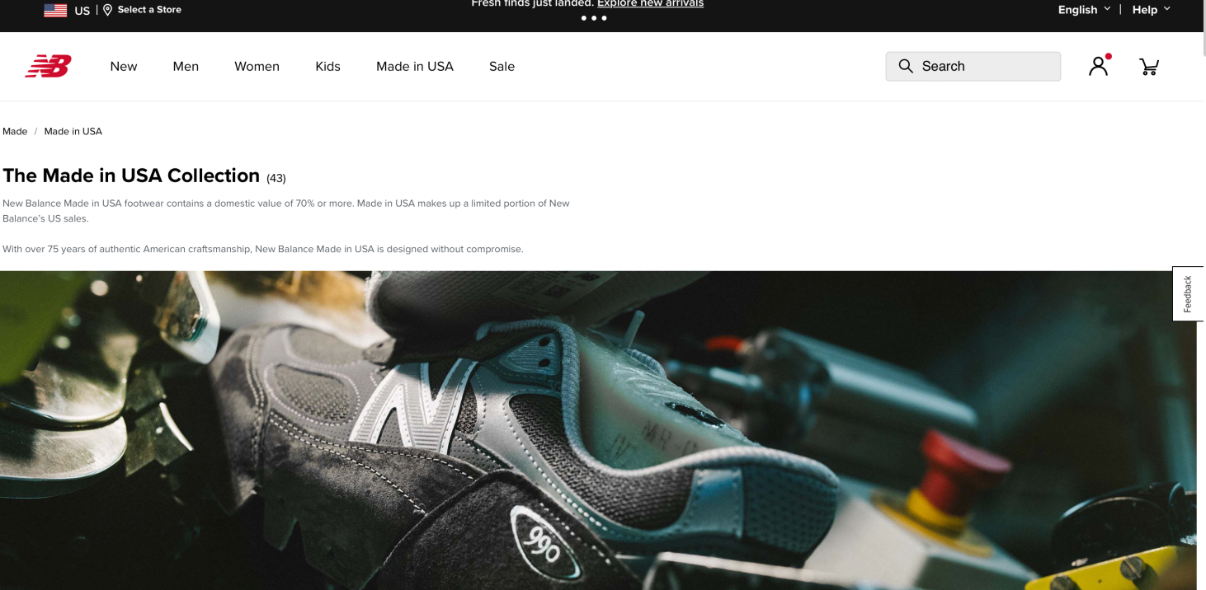
SEO – Alt Text and Accessibility | In several places images lack visible alt descriptions or labeling, which can harm both SEO and accessibility compliance. | 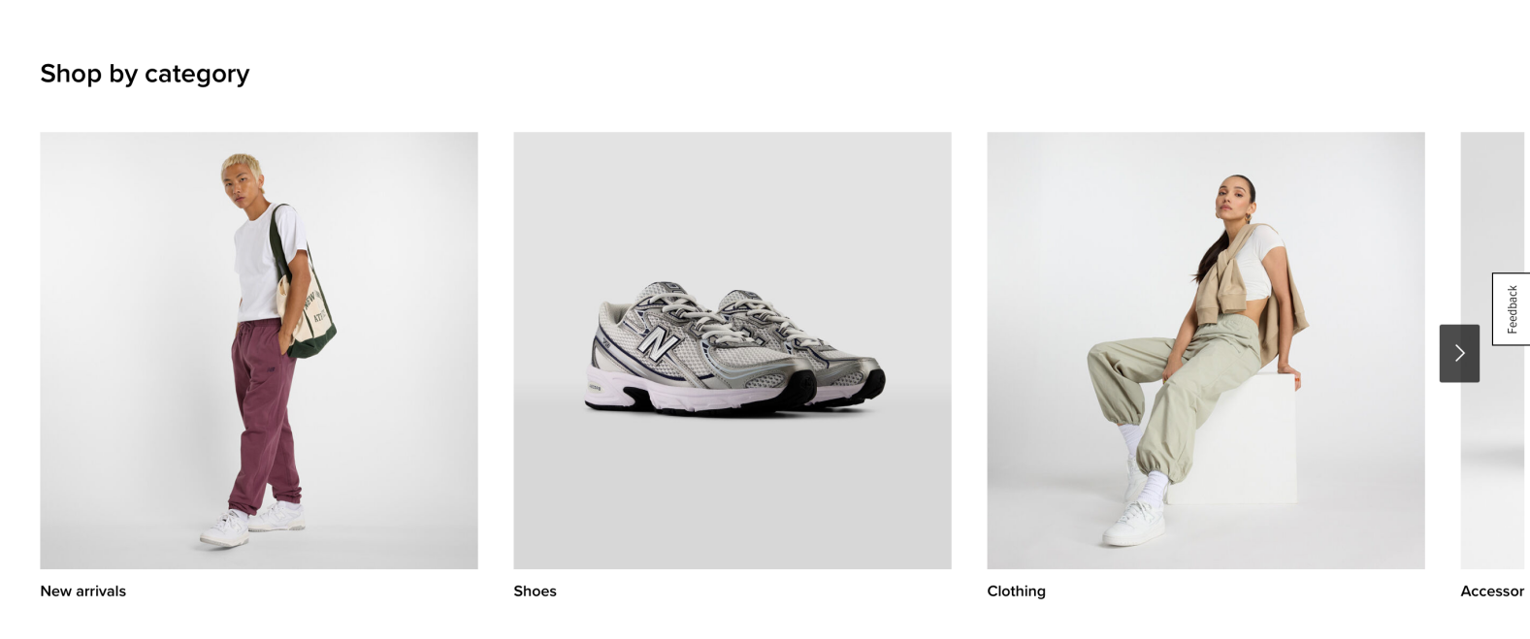

PART 3: SEM
Keyword Criteria | Keywords Selected | Did LUSH Show Up? | Results Description | Screenshot
1. High volume keyword (no brand name) | running shoes USA | Yes — New Balance appears visually in image results (e.g., Image 1, left column). Organic presence noted but dominated by generic guides and competitors like Hoka and Brooks. Paid ads by other brands. | 1. High volume keyword (no brand name) | 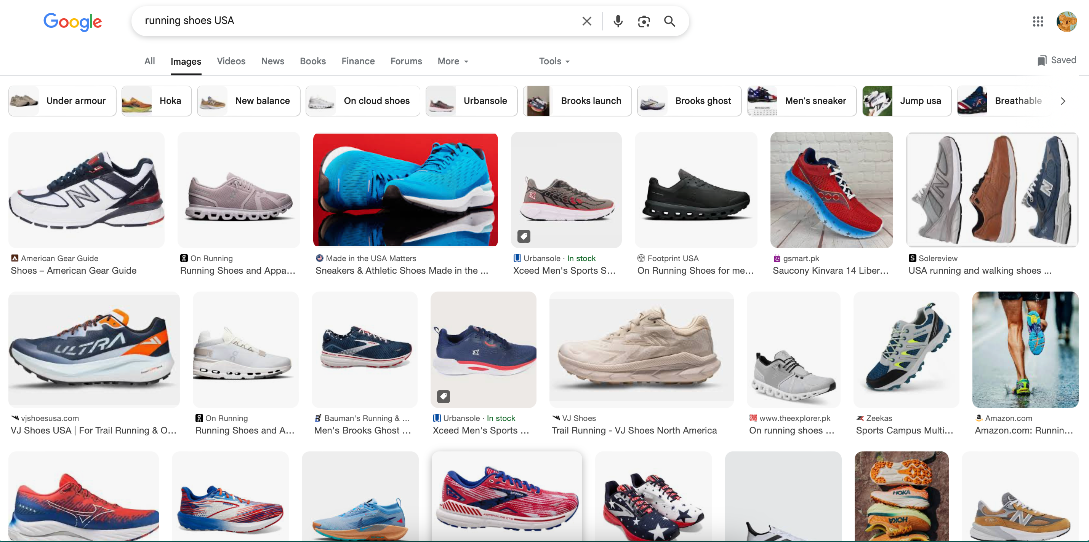
2. Low volume keyword (no brand name) | trail running shoes Vibram outsole | Yes — New Balance appears among technical Vibram outsole products (Image 2), but no direct paid ad. Competitors such as Norda, Topo, and Joe Nimble lead the image results. | 2. Low volume keyword (no brand name) | 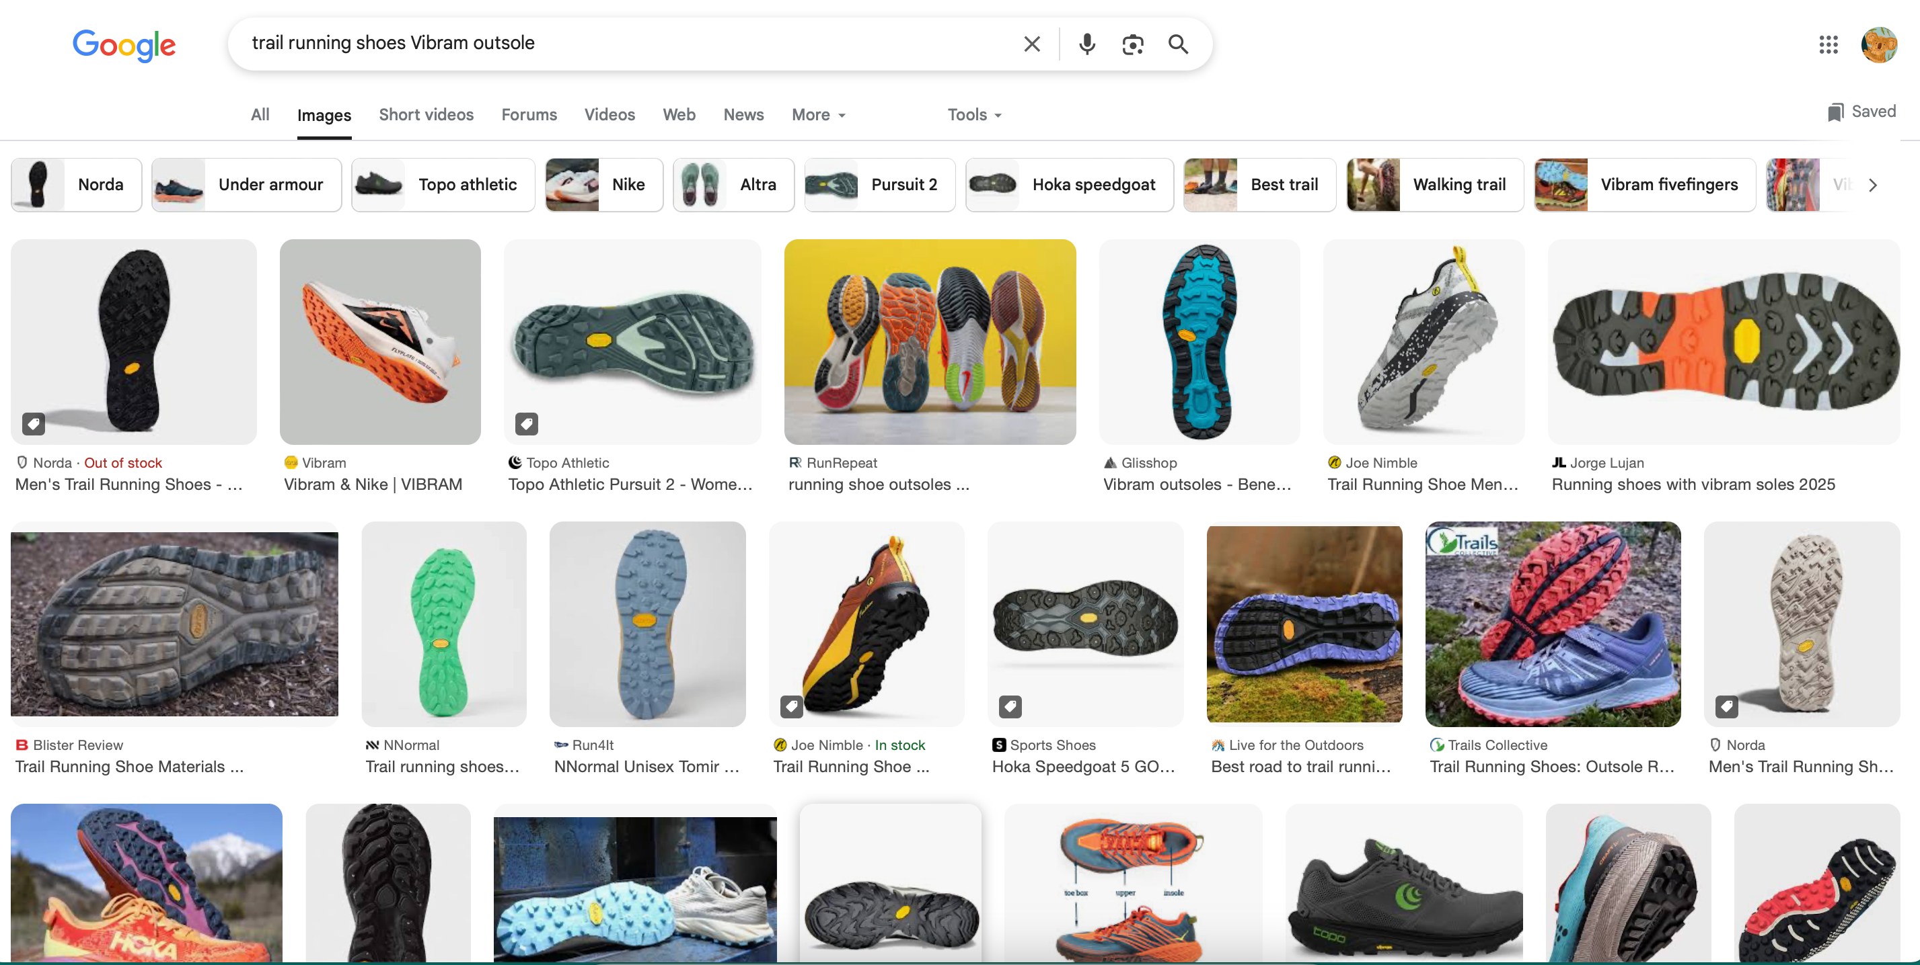
3. Long-tail keyword (no brand name) | comfortable cushioned running shoes for wide feet USA | Yes — New Balance shown in multiple curated lists and review articles (Image 3). Strong organic visibility via third-party endorsement (e.g., Healthline, Runner’s World), but no paid search ads from NB. | 3. Long-tail keyword (no brand name) | 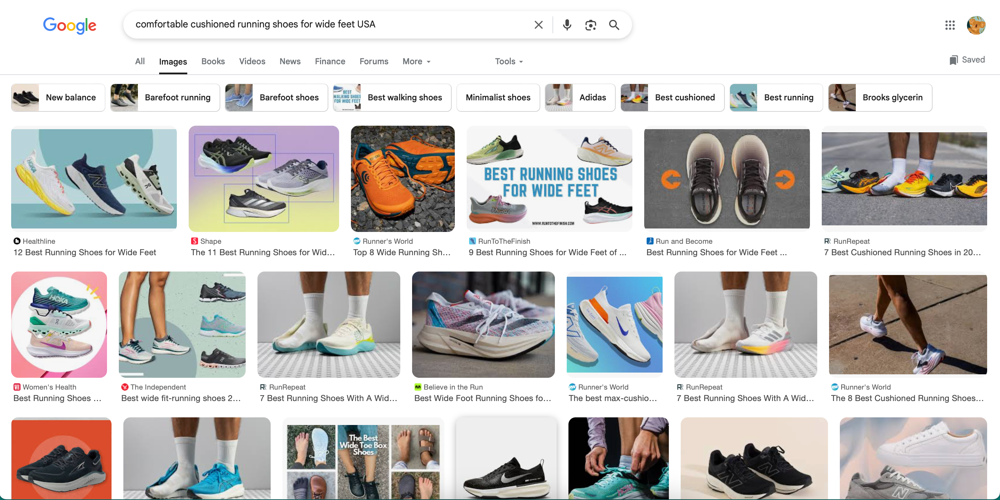

PART 4: Recommendations & Impact

Area of Focus | Recommendations | Impact on Target Audience (AIDAR Framework)
Website | Improve filter visibility on product listing pages (PLPs), especially for technical categories like “trail running” and “wide fit.” | Enhances Attention and Interest by allowing the user (e.g., Sarah the fitness coach) to find the right product faster. Reduces frustration, which can increase Desire and eventually lead to Action (purchase).
SEO | Add structured data (schema.org markup) and custom meta descriptions for key collection pages (e.g., “Made in USA”). | Boosts Visibility and Relevance in SERPs, especially for sustainability-focused users. This improves Attention and organic discovery, making New Balance more competitive for eco-aware segments.
SEM | Run targeted Google Ads for long-tail search terms like “best cushioned shoes for wide feet.” | Targets high-intent users who are already looking for solutions New Balance offers. This creates Desire and increases Conversionlikelihood (Action) by putting NB ahead of generic blog links.
SEO / SEM | Launch a blog section covering topics like “Trail vs. Road Running Shoes” and “Why Choose Made in USA?” | Builds Interest and Trust (ethos), positioning NB as a knowledgeable authority. This nurtures Desire and drives traffic over time via evergreen SEO content.
Website / SEO | Add alt text to all product and campaign images for accessibility compliance and image SEO. | Improves Accessibility and contributes to SEO ranking. Enhances Awareness among visually impaired users and improves Trust in the brand’s inclusivity and professionalism.

PART 5: Before and After Visuals

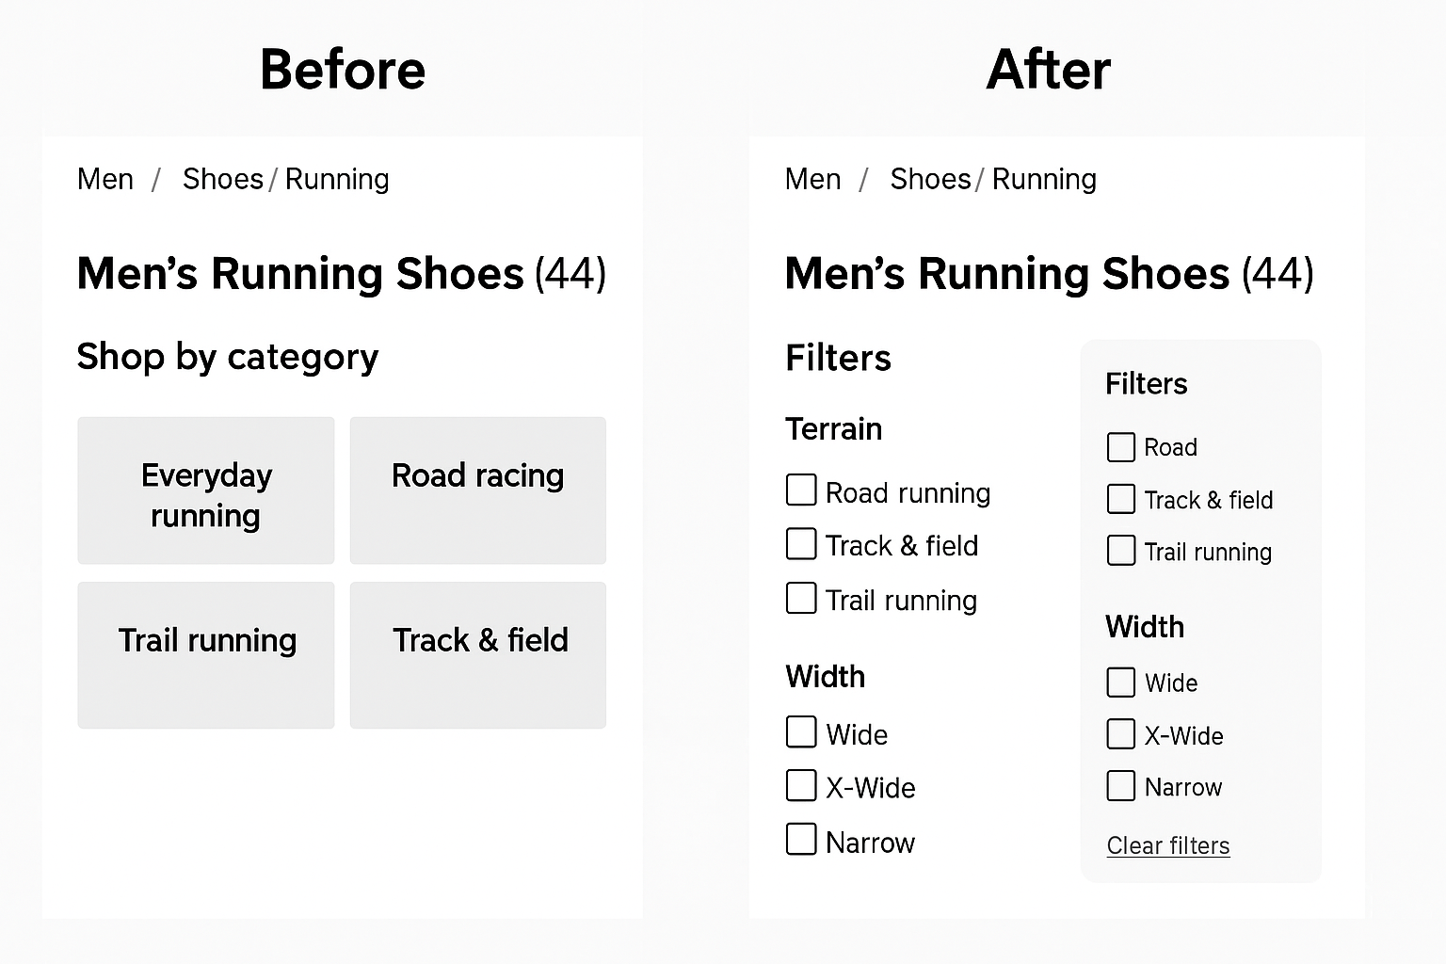

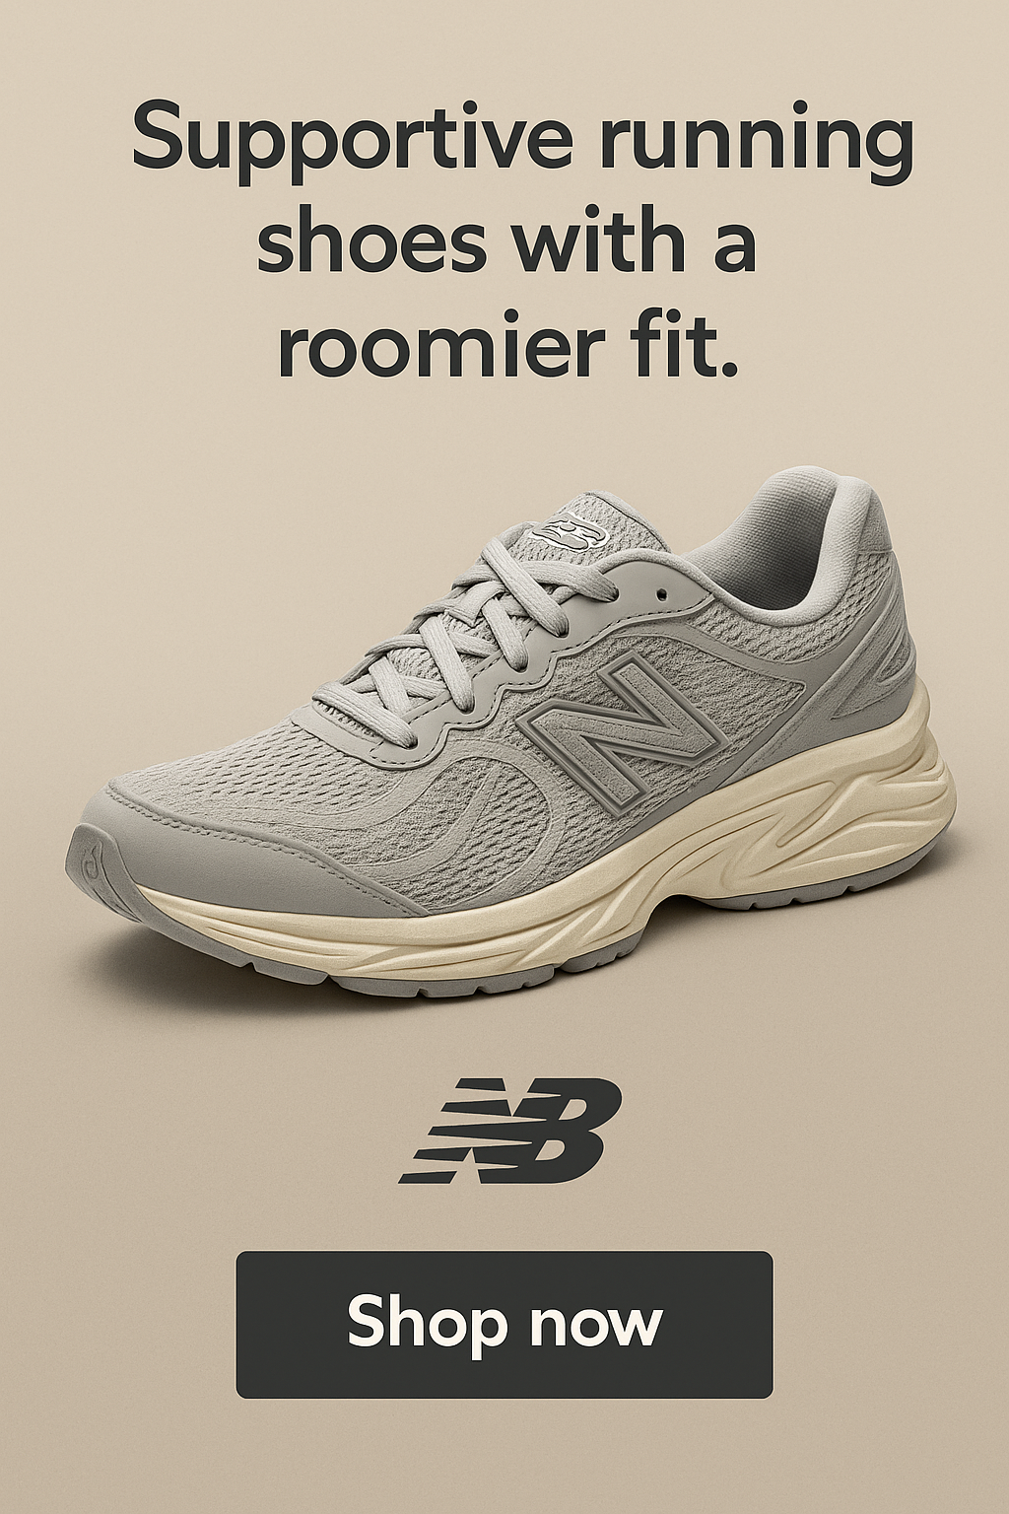

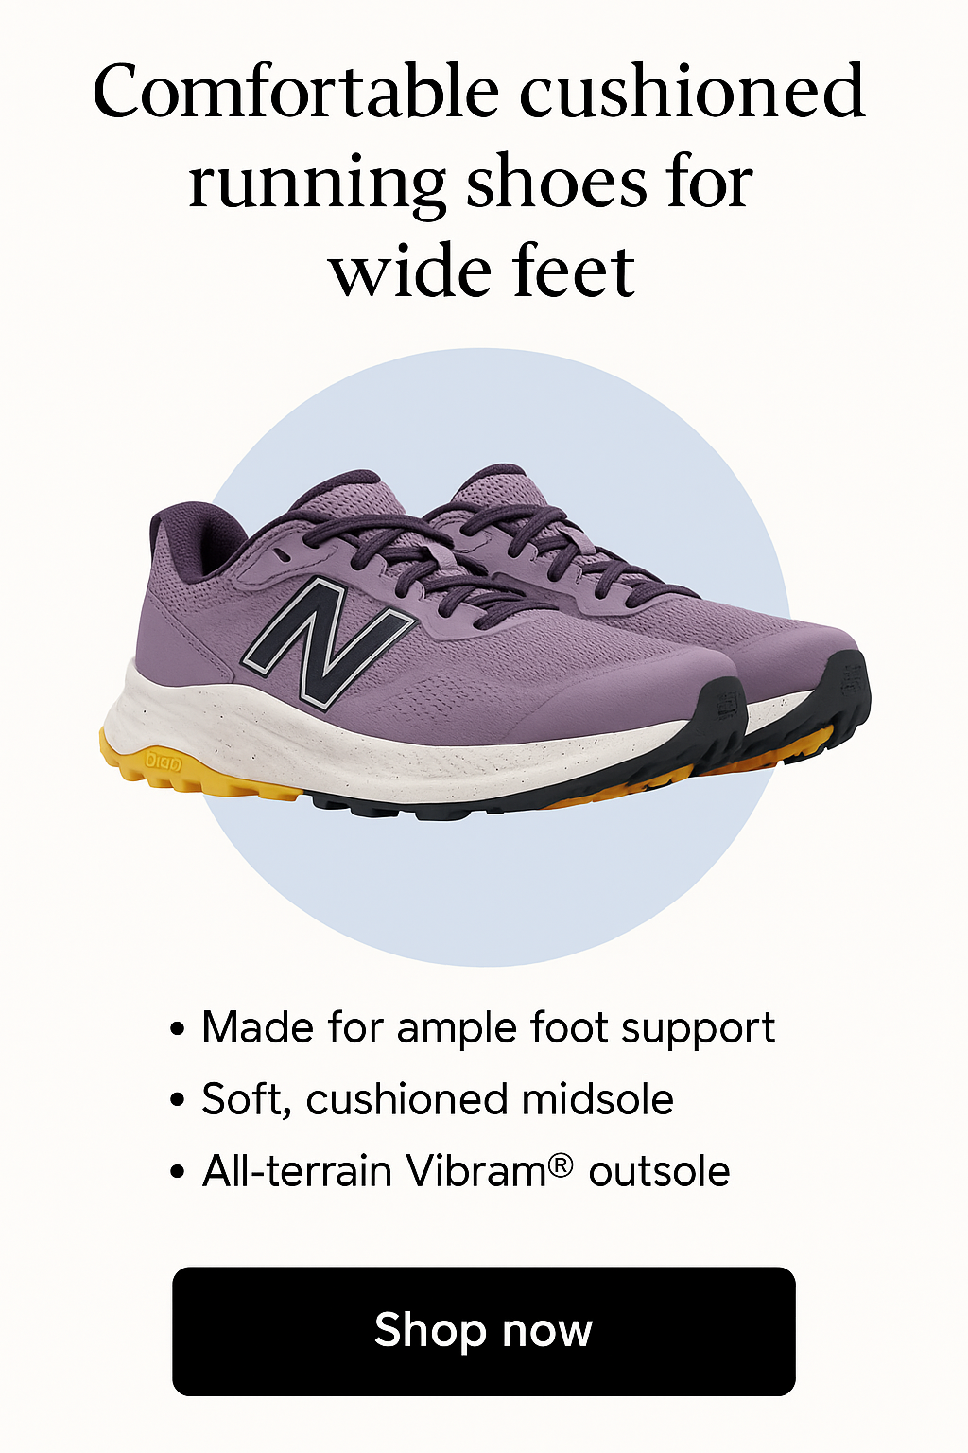

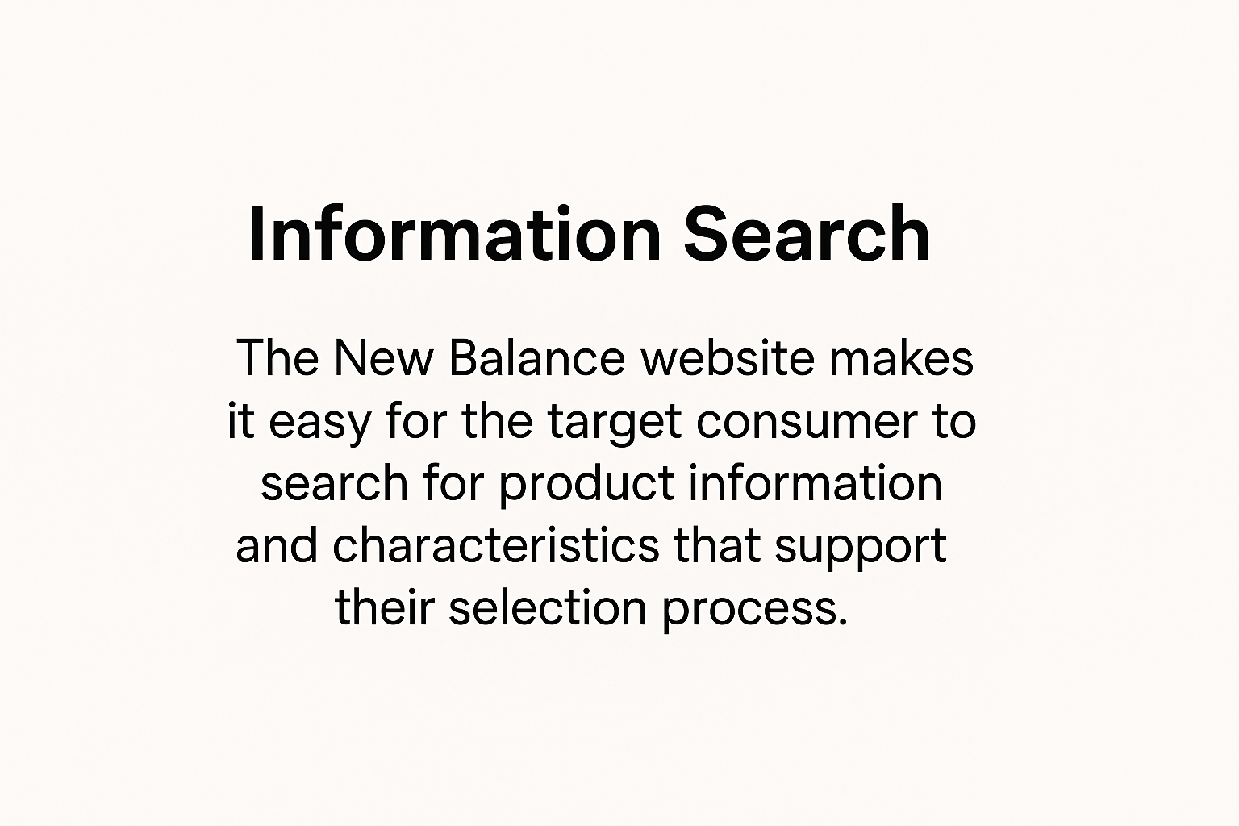

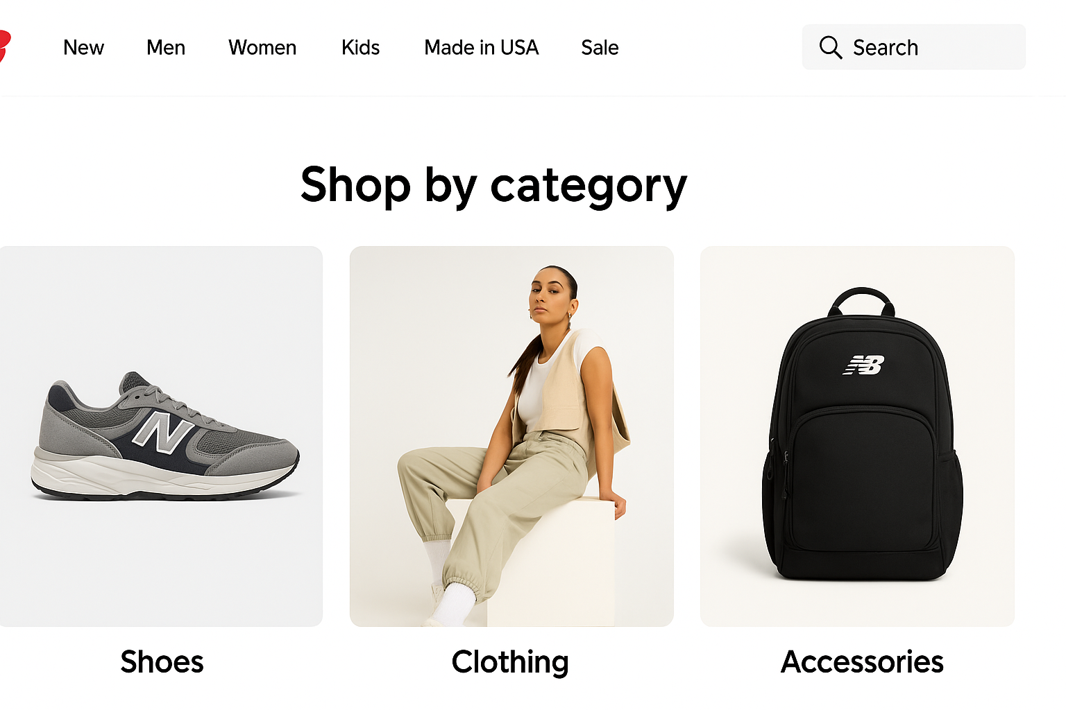
PART 6: REFLECTION GRID

Submission Components | Falls Below Requirements | Met Requirements | Exceeds the Requirements | Self-Assessment (1–3 Sentences)
Part 1: Context |  |  | ✅ | I provided detailed brand voice analysis, AIDAR-based goals, and a specific audience persona grounded in both psychographic and demographic factors.
Part 2: Website Evaluation |  |  | ✅ | I identified best practices and actual usability/SEO issues using annotated visuals and course-based checklists.
Part 3: SEM |  |  | ✅ | I ran live SERP tests using three tiers of keywords and supported analysis with screenshots and competitor insights.
Part 4: Recommendations & Impact |  |  | ✅ | I delivered actionable, specific suggestions aligned with AIDAR and described clear behavioral impacts on users.
Part 5: Before and After Creative |  |  | ✅ | I created original before/after visuals using mockups for UI filters, targeted ads, and category structures that directly reflect audit findings.

